实验4 JSP
一．实验目的
理解JSP的结构；掌握JSP的编写和运行；掌握使用JSP+Servlet+JavaBean开发模式开发实现基本功能模块；使用学习过的Web前端的JS完成分页展示功能；掌握JSTL和EL在JSP页面中的使用方法，理解其基本原理。
二. 实验环境
硬件：PC系列微机，CPU1.2G以上，内存512M以上
软件：Windows 11； edge浏览器、JDK1.8、Eclipse Version: Oxygen.3a Release (4.7.3a)、Tomcat8.0.26、MySQL8.0等。
三. 实验内容
1、使用集成开发软件创建Java web项目并编写显示自己姓名的一个JSP文件。
2、在步骤1的JSP中使用如下注释：
<!-- This file displays the user login screen -->
<!--This page was loaded on <%= (new java.util.Date()).toLocaleString() %> -->
<%-- This comment will not be visible in the page source --%>
在浏览器中查看注释的显示情况。
3、测试使用包含指令@page include。
请编写如下所示的多个JSP文件。再使用包含指令将这些文件引入到main.jsp，以实现布局的统一。
header.jsp（头部）
leftMenu.jsp（左侧菜单）  --学生列表  --学生选课 | listStudent.jsp（主内容区，显示点击菜单后结果）  <首页><上一页><下一页><尾页>
footer.jsp（页尾）
4、使用JSP+Servlet+JavaBean开发模式开发实现学生登录、注册和列表功能、编辑学生信息、删除学生功能。登陆后显示main.jsp，点击学生列表菜单，要求在main.jsp的主内容区以分页形式展示学生记录列表、列表页面中使用JSTL和EL替代脚本段。
四. 实验过程
1、使用集成开发软件创建Java web项目并编写显示自己姓名的一个JSP文件。
实现截图：
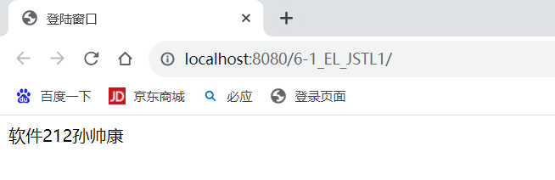
代码：name.jsp
<%@ page language="java" contentType="text/html; charset=utf-8"
pageEncoding="utf-8"%>
<!DOCTYPE html PUBLIC "-//W3C//DTD HTML 4.01 Transitional//EN" "http://www.w3.org/TR/html4/loose.dtd">
<html>
<head>
<meta http-equiv="Content-Type" content="text/html; charset=utf-8">
<title>name</title>
</head>
<body>
软件212孙帅康
</body>
</html>
2、在步骤1的JSP中使用如下注释：
<!-- This file displays the user login screen -->
<!--This page was loaded on <%= (new java.util.Date()).toLocaleString() %> -->
<%-- This comment will not be visible in the page source --%>
在浏览器中查看注释的显示情况。
显示情况为：
<!-- This file displays the user login screen -->
<!--This page was loaded on 2023-11-12 14:01:39 -->
代码截图：
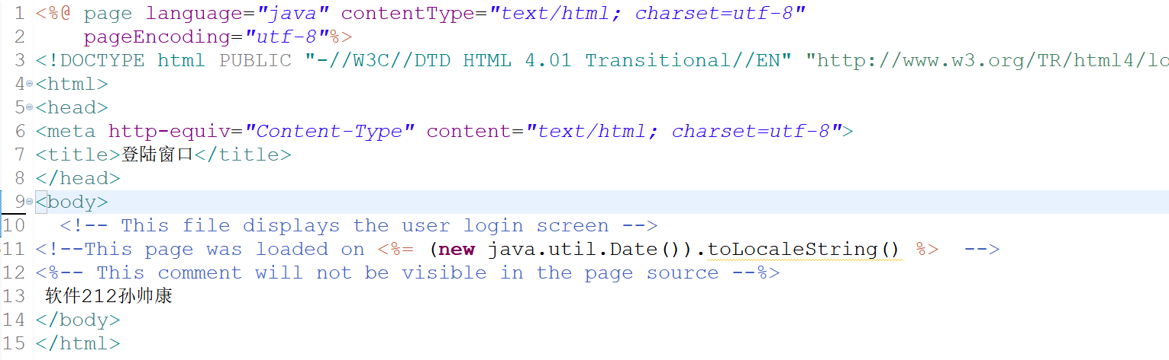
声明并不在JSP页内产出任何输出。它们仅仅用于定义，不能生成输出结果。
3、测试使用包含指令@page include。
请编写如下所示的多个JSP文件。再使用包含指令将这些文件引入到main.jsp，以实现布局的统一。
header.jsp（头部）
leftMenu.jsp（左侧菜单）  --学生列表  --学生选课 | listStudent.jsp（主内容区，显示点击菜单后结果）  <首页><上一页><下一页><尾页>
footer.jsp（页尾）
实现截图：
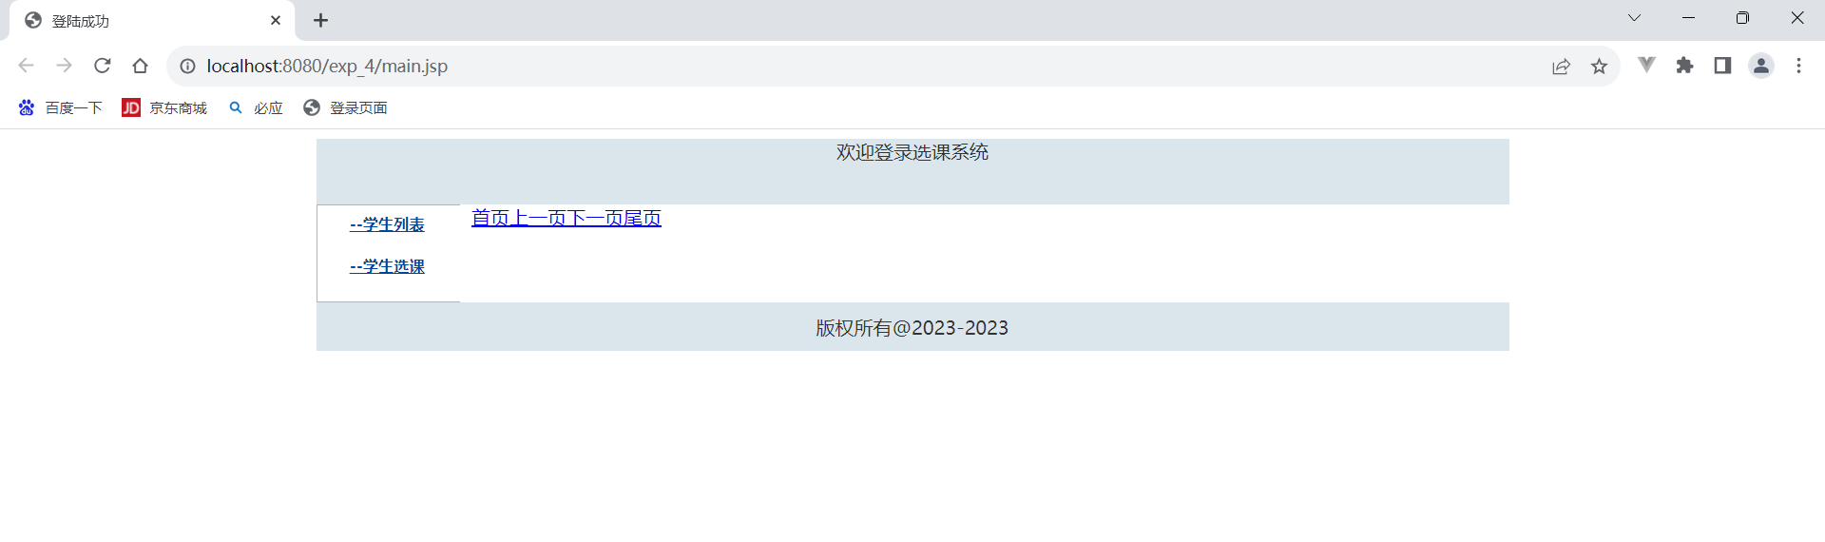
实现代码：
footer.jsp
<%@ page language="java" contentType="text/html; charset=utf-8"
pageEncoding="utf-8"%>
<!DOCTYPE html PUBLIC "-//W3C//DTD HTML 4.01 Transitional//EN" "http://www.w3.org/TR/html4/loose.dtd">
<html>
<head>
<meta http-equiv="Content-Type" content="text/html; charset=utf-8">
<title>登陆窗口</title>
</head>
<body>
<div>版权所有@2023-2023</div>
</body>
</html>
Header.jsp
<%@ page language="java" contentType="text/html; charset=utf-8"
pageEncoding="utf-8"%>
<!DOCTYPE html PUBLIC "-//W3C//DTD HTML 4.01 Transitional//EN" "http://www.w3.org/TR/html4/loose.dtd">
<html>
<head>
<meta http-equiv="Content-Type" content="text/html; charset=utf-8">
<title>登陆窗口</title>
</head>
<body>
<div align="center">欢迎登录选课系统</div>
</body>
</html>
listMenu.jsp
<%@ page language="java" contentType="text/html; charset=utf-8"
pageEncoding="utf-8"%>
<!DOCTYPE html PUBLIC "-//W3C//DTD HTML 4.01 Transitional//EN" "http://www.w3.org/TR/html4/loose.dtd">
<html>
<head>
<meta http-equiv="Content-Type" content="text/html; charset=utf-8">
<title>登陆窗口</title>
</head>
<body>
<div>
<ul>
<li><a href="listStudent.jsp">--学生列表</a></li>
<li><a href="#">--学生选课</a></li>
</ul>
</div>
</body>
</html>
listStudent.jsp
<%@ page language="java" contentType="text/html; charset=utf-8"
pageEncoding="utf-8"%>
<!DOCTYPE html PUBLIC "-//W3C//DTD HTML 4.01 Transitional//EN" "http://www.w3.org/TR/html4/loose.dtd">
<html>
<head>
<meta http-equiv="Content-Type" content="text/html; charset=utf-8">
<title>登陆窗口</title>
</head>
<body>
<div><a href="#">首页</a><a href="#">上一页</a><a href="#">下一页</a><a href="#">尾页</a></div>
</body>
</html>
Main.jsp
<%@ page language="java" contentType="text/html; charset=utf-8" pageEncoding="utf-8" errorPage="error.jsp" %>

<!DOCTYPE html PUBLIC "-//W3C//DTD HTML 4.01 Transitional//EN" "http://www.w3.org/TR/html4/loose.dtd">
<html>
<head>
<meta http-equiv="Content-Type" content="text/html; charset=utf-8">
<title>登陆成功</title>
<link rel="stylesheet" type="text/css" href="css/style.css" />
</head>
<body>
<div id="wrapper">
<!-- header -->
<div class="header">
<%@ include file="header.jsp" %>
</div>
<!-- menu -->
<div class="menu">
<%@ include file="leftMenu.jsp" %>
</div>
<!-- content -->
<div class="content">
<%@ include file="listStudent.jsp" %>
</div>
<!-- footer -->
<div class="footer">
<%@ include file="footer.jsp" %>
</div>
</div>
</body>
</html>

- 使用JSP+Servlet+JavaBean开发模式开发实现学生登录、注册和列表功能、编辑学生信息、删除学生功能。登陆后显示main.jsp，点击学生列表菜单，要求在main.jsp的主内容区以分页形式展示学生记录列表、列表页面中使用JSTL和EL替代脚本段。
- 学生登录
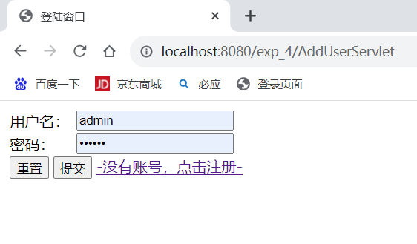
登录界面Index.jsp
<%@ page language="java" contentType="text/html; charset=utf-8"
pageEncoding="utf-8"%>
<!DOCTYPE html PUBLIC "-//W3C//DTD HTML 4.01 Transitional//EN" "http://www.w3.org/TR/html4/loose.dtd">
<html>
<head>
<meta http-equiv="Content-Type" content="text/html; charset=utf-8">
<title>登陆窗口</title>
</head>
<body>
<form action="LoginValid.jsp" method="post">
<table border=0>
<tr><td>用户名：</td><td><input name='name' type='text' value=''/></td></tr>
<tr><td>密码：</td><td><input name='password' type='password' value=''/></td></tr>
<tr><td colspan=2 align=right>
<input type="reset" value="重置" class="btn">
<input type='submit' value='提交'/>
<a href="${pageContext.request.contextPath}/AddUser.jsp">-没有账号，点击注册-</a></td>
</tr>
<tr><td colspan=2 align=right>${error}</td></tr>
</table>
${error}<br/>
</form>
</body>
</html>
登录检查LoginCheck.jsp
<%
request.setCharacterEncoding("utf-8");
response.setCharacterEncoding("utf-8");
%>

<c:if test="${empty user.username}" var="username">
<c:redirect url="/index.jsp"/>
</c:if>
LoginValid.jsp
<%@ page language="java" contentType="text/html; charset=UTF-8" pageEncoding="UTF-8" errorPage="/error.jsp"%>
<%@ taglib uri="http://java.sun.com/jsp/jstl/core" prefix="c"%>
<body>
<jsp:useBean id="user" class="bean.UserBean"/>
<jsp:setProperty name="user" property="username" param="name"/>
<jsp:setProperty name="user" property="password"/>
<c:set var="successflag" value="${user.validlogin()}"/>
<c:choose>
<c:when test="${successflag}">
<c:set var="user" value="${user}" scope="session"/>
<c:redirect url="main.jsp"/>
</c:when>
<c:otherwise>
<jsp:forward page="index.jsp">
<jsp:param value="error" name="用户名或密码不正确，登陆失败！"/>
</jsp:forward>
</c:otherwise>
</c:choose>
</body>
- 学生注册
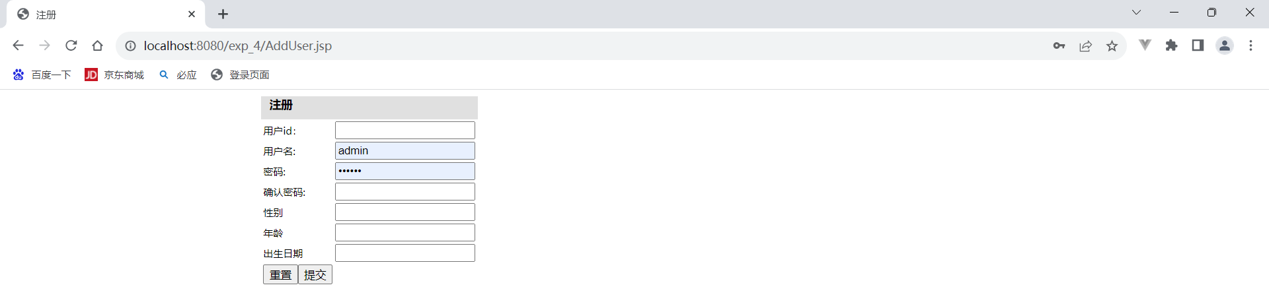
注册admin20 123456的学生用户
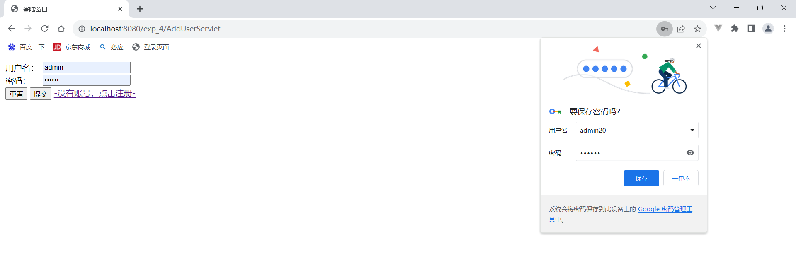
利用此账号登录。
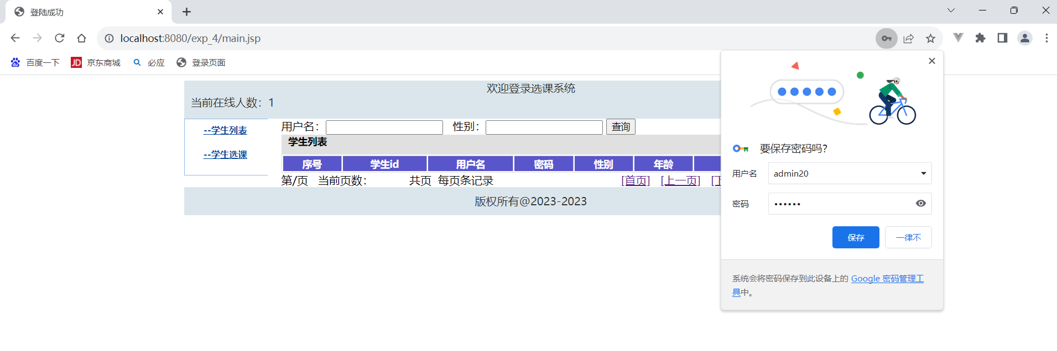
AddUser.jsp
<%@ page language="java" contentType="text/html; charset=utf-8" pageEncoding="utf-8" errorPage="/error.jsp" %>
<%@ taglib uri="http://java.sun.com/jsp/jstl/core" prefix="c"%>

<!DOCTYPE html PUBLIC "-//W3C//DTD HTML 4.01 Transitional//EN" "http://www.w3.org/TR/html4/loose.dtd">
<html>
<head>
<meta http-equiv="Content-Type" content="text/html; charset=utf-8">
<title>注册</title>
<link rel="stylesheet" type="text/css" href="${pageContext.request.contextPath}/css/style.css" />
<link rel="stylesheet" type="text/css" href="${pageContext.request.contextPath}/css/common.css" />
</head>
<body>
<!-- content -->
<div class="content">
<form action="${pageContext.request.contextPath}/AddUserServlet" method="post">
<table class="mtable3" align=center>
<caption>注册</caption>
<tr><td>用户id：</td>
<td><input type="text" name="userid" value="${newuser.userid}"/>${errors.userid}</td></tr>
<tr><td>用户名:</td>
<td><input type="text" name="username" value="${newuser.username}"/>${errors.username}</td></tr>
<tr>
<td>密码:</td><td><input type="password" name="password"/>${errors.password}</td></tr>
<tr>
<td>确认密码:</td><td><input type="password" name="confirmpassword"/>${errors.confirmpassword}</td></tr>
<tr><td>性别</td><td><input type="text" name="sex" value="${newuser.sex}"/></td></tr>
<tr><td>年龄</td><td><input type="text" name="age" value="${newuser.age}"/></td></tr>
<tr><td>出生日期</td><td><input type="text" name="birthday" value="${newuser.birthday}"/></td></tr>
<tr><td><input type="reset" value="重置"/><input type="submit" value="提交"/></td></tr>
</table>
${errors.othererr}
</form>
</div></body></html>
AddUserServlet.java
package servlet;

import java.io.IOException;
import java.util.Map;

import javax.servlet.ServletException;
import javax.servlet.annotation.WebServlet;
import javax.servlet.http.HttpServlet;
import javax.servlet.http.HttpServletRequest;
import javax.servlet.http.HttpServletResponse;

import bean.UserBean;

/**
* Servlet implementation class AddUserServlet
*/
@WebServlet("/AddUserServlet")
public class AddUserServlet extends HttpServlet {
private static final long serialVersionUID = 1L;

/**
* @see HttpServlet#HttpServlet()
*/
public AddUserServlet() {
super();
// TODO Auto-generated constructor stub
}

/**
* @see HttpServlet#doGet(HttpServletRequest request, HttpServletResponse response)
*/
protected void doGet(HttpServletRequest request, HttpServletResponse response) throws ServletException, IOException {
request.setCharacterEncoding("utf-8");
response.setCharacterEncoding("utf-8");

UserBean newuser=new UserBean();
newuser.setUserid(request.getParameter("userid"));
newuser.setUsername(request.getParameter("username"));
newuser.setSex(request.getParameter("sex"));
String age=request.getParameter("age");
if(age.equals("")) age=null;
newuser.setAge(age);
newuser.setBirthday(request.getParameter("birthday"));
newuser.setPassword(request.getParameter("password"));
newuser.setConfirmpassword(request.getParameter("confirmpassword"));

Map<String, String> errors=null;
try{
errors=newuser.checkUser();
if(errors.size()==0) newuser.addUser();
}catch(Exception e){
errors.put("othererr", "注册失败："+e.getMessage());
}
if(errors.size()!=0){
request.setAttribute("errors", errors);
request.getRequestDispatcher("/AddUser.jsp").forward(request, response);
}else{
request.getRequestDispatcher("/index.jsp").forward(request, response);
}
}

/**
* @see HttpServlet#doPost(HttpServletRequest request, HttpServletResponse response)
*/
protected void doPost(HttpServletRequest request, HttpServletResponse response) throws ServletException, IOException {
// TODO Auto-generated method stub
doGet(request, response);
}
}
- 学生列表
Main.jsp
<%@ page language="java" contentType="text/html; charset=utf-8" pageEncoding="utf-8" errorPage="error.jsp" %>

<!DOCTYPE html PUBLIC "-//W3C//DTD HTML 4.01 Transitional//EN" "http://www.w3.org/TR/html4/loose.dtd">
<html>
<head>
<meta http-equiv="Content-Type" content="text/html; charset=utf-8">
<title>登陆成功</title>
<link rel="stylesheet" type="text/css" href="css/style.css" />
</head>
<body>
<div id="wrapper">
<!-- header -->
<div class="header">
<%@ include file="header.jsp" %>
</div>
<!-- menu -->
<div class="menu">
<%@ include file="leftMenu.jsp" %>
</div>
<!-- content -->
<div class="content">
<%@ include file="listStudent.jsp" %>
</div>
<!-- footer -->
<div class="footer">
<%@ include file="footer.jsp" %>
</div>
</div>
</body>
</html>
- 编辑学生信息
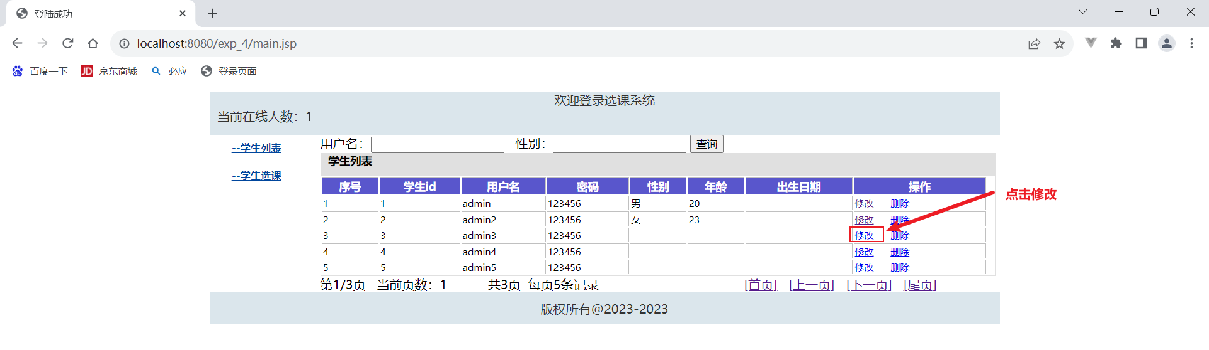
对各项信息可修改并保存
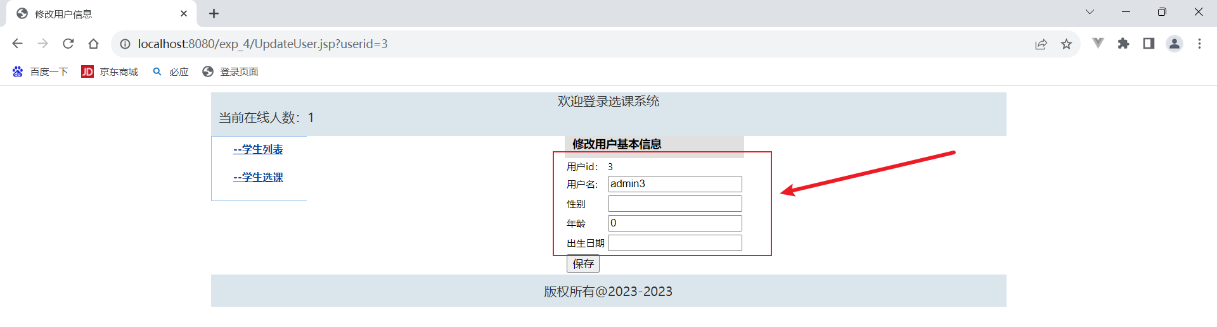
UpdateUserServlet.java
package servlet;

import java.io.IOException;
import java.util.HashMap;
import java.util.Map;

import javax.servlet.ServletException;
import javax.servlet.annotation.WebServlet;
import javax.servlet.http.HttpServlet;
import javax.servlet.http.HttpServletRequest;
import javax.servlet.http.HttpServletResponse;

import bean.UserBean;

/**
* Servlet implementation class UpdateUserServlet
*/
@WebServlet("/UpdateUserServlet")
public class UpdateUserServlet extends HttpServlet {
private static final long serialVersionUID = 1L;

/**
* @see HttpServlet#HttpServlet()
*/
public UpdateUserServlet() {
super();
// TODO Auto-generated constructor stub
}

/**
* @see HttpServlet#doGet(HttpServletRequest request, HttpServletResponse response)
*/
protected void doGet(HttpServletRequest request, HttpServletResponse response) throws ServletException, IOException {
request.setCharacterEncoding("utf-8");
UserBean user=this.getUserFromRequest(request);
Map<String,String> errors=this.valid(user);
try {
user.updateUser();
} catch (Exception e) {
errors.put("othererr", "更新数据失败："+e.getMessage());
}
if(errors.size()!=0){
request.setAttribute("errors", errors);
request.setAttribute("updateuser", user);
request.getRequestDispatcher("/UpdateUser.jsp").forward(request, response);
}else{
response.sendRedirect(request.getContextPath()+"/main.jsp");
}
}

private Map<String,String> valid(UserBean user){
Map<String,String> errors=new HashMap<String,String>();
if(user.getUsername().equals("")) errors.put("username", "用户名不能为空！");
return errors;
}
private UserBean getUserFromRequest(HttpServletRequest request){
String userid=request.getParameter("userid");
String username=request.getParameter("username");
String sex=request.getParameter("sex");
String age=request.getParameter("age");
String birthday=request.getParameter("birthday");

UserBean user=new UserBean();
user.setUserid(userid);
user.setUsername(username);
user.setSex(sex);
user.setAge(age);
user.setBirthday(birthday);

return user;
}
protected void doPost(HttpServletRequest request, HttpServletResponse response) throws ServletException, IOException {
doGet(request,response);
}}
UpdateUser.jsp
<%@ page language="java" contentType="text/html; charset=utf-8" pageEncoding="utf-8" errorPage="/error.jsp" %>
<%@ taglib uri="http://java.sun.com/jsp/jstl/core" prefix="c"%>

<%@ include file="/LoginCheck.jsp" %>
<c:if test="${empty updateuser}">
<c:set var="userid" value="${param.userid}"/>
<jsp:useBean id="userbpo" class="bpo.UserBpo"/>
<c:set var="updateuser" value="${userbpo.getUserById(userid)}"/>
</c:if>
<!DOCTYPE html PUBLIC "-//W3C//DTD HTML 4.01 Transitional//EN" "http://www.w3.org/TR/html4/loose.dtd">
<html>
<head>
<meta http-equiv="Content-Type" content="text/html; charset=utf-8">
<title>修改用户信息</title>
<link rel="stylesheet" type="text/css" href="${pageContext.request.contextPath}/css/style.css" />
<link rel="stylesheet" type="text/css" href="${pageContext.request.contextPath}/css/common.css" />
</head>
<body>
<div id="wrapper">
<!-- header -->
<div class="header">
<jsp:include page="/header.jsp" flush="true"/>
</div>
<!-- menu -->
<div class="menu">
<jsp:include page="/leftMenu.jsp"/>
</div>
<!-- content -->
<div class="content">
<form action="${pageContext.request.contextPath}/UpdateUserServlet" method="post">
<table class="mtable3" align=center>
<caption>修改用户基本信息</caption>
<tr><td>用户id：</td>
<td><input type="hidden" name="userid"
value="${updateuser.userid}"/>${updateuser.userid}</td></tr>
<tr><td>用户名:</td>
<td><input type="text" name="username"
value="${updateuser.username}"/>${errors.username}</td></tr>
<tr><td>性别</td>
<td><input type="text" name="sex" value="${updateuser.sex}"/></td></tr>
<tr><td>年龄</td>
<td><input type="text" name="age" value="${updateuser.age}"/></td></tr>
<tr><td>出生日期</td>
<td><input type="text" name="birthday" value="${updateuser.birthday}"/></td></tr>
<tr><td><input type="submit" value="保存"/></td></tr>
</table>
${errors.othererr}
</form>
</div>
<!-- footer -->
<div class="footer">
<jsp:include page="/footer.jsp" flush="true"/>
</div>
</div>

</body>
</html>
- 删除学生功能
点击删除
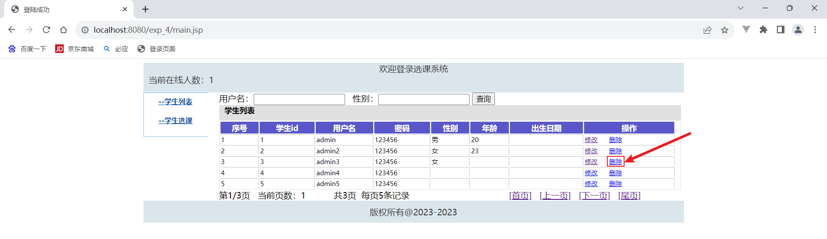
已删除
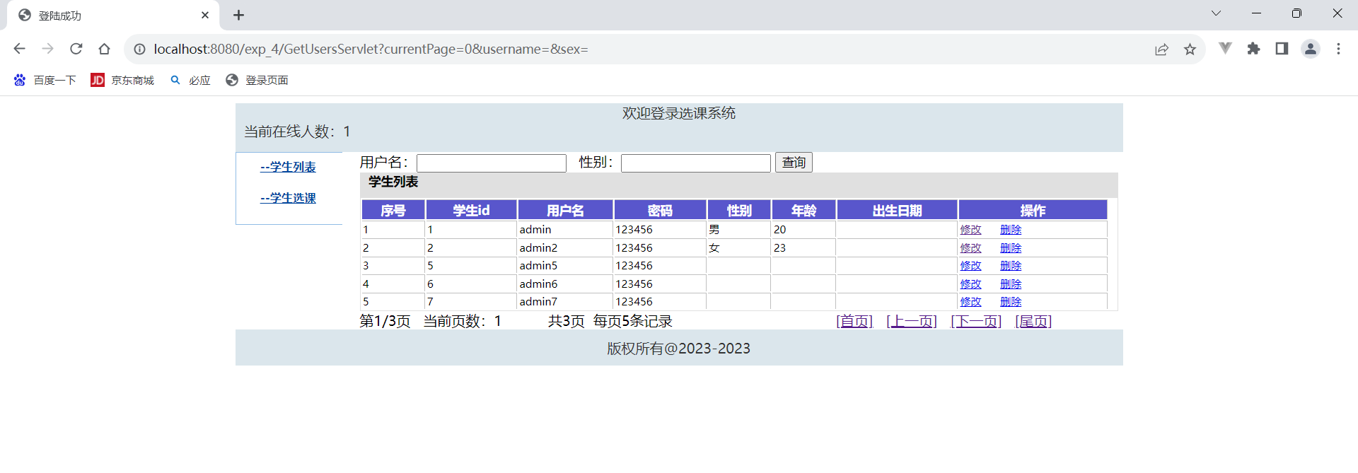
DeleteUserServlet.java
package servlet;

import java.io.IOException;
import javax.servlet.ServletException;
import javax.servlet.annotation.WebServlet;
import javax.servlet.http.HttpServlet;
import javax.servlet.http.HttpServletRequest;
import javax.servlet.http.HttpServletResponse;

import bean.UserBean;

/**
* Servlet implementation class DeleteUserServlet
*/
@WebServlet("/DeleteUserServlet")
public class DeleteUserServlet extends HttpServlet {
private static final long serialVersionUID = 1L;

/**
* @see HttpServlet#HttpServlet()
*/
public DeleteUserServlet() {
super();
// TODO Auto-generated constructor stub
}

/**
* @see HttpServlet#doGet(HttpServletRequest request, HttpServletResponse response)
*/
protected void doGet(HttpServletRequest request, HttpServletResponse response) throws ServletException, IOException {
request.setCharacterEncoding("utf-8");

String userid=request.getParameter("userid");
String error="";
try{
UserBean userbean=new UserBean();
userbean.setUserid(userid);
userbean.delUserById();
}catch(Exception e){
error="删除[userid:"+userid+"]出错："+e.getMessage();
}
request.setAttribute("error", error);
request.getRequestDispatcher("/GetUsersServlet").forward(request,response);
}

/**
* @see HttpServlet#doPost(HttpServletRequest request, HttpServletResponse response)
*/
protected void doPost(HttpServletRequest request, HttpServletResponse response) throws ServletException, IOException {
// TODO Auto-generated method stub
doGet(request, response);
}}
- 分页展示查询学生记录
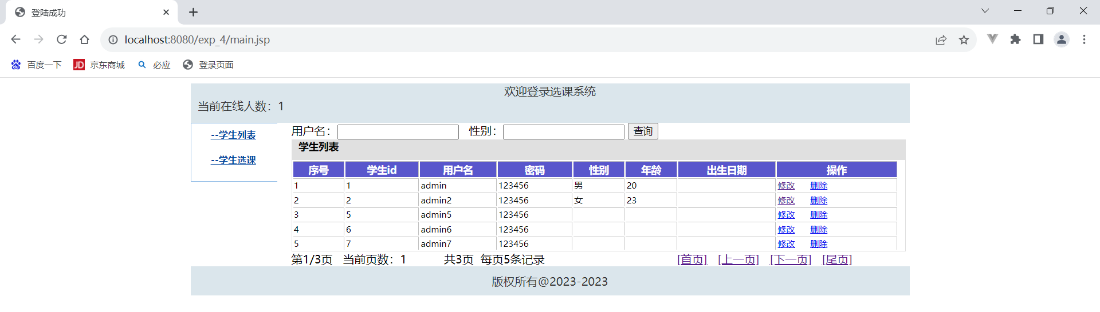
查询男的学生用户
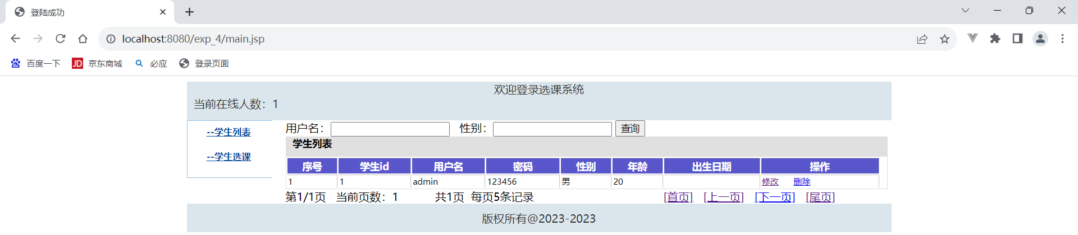
package servlet;

import java.io.IOException;
import java.util.ArrayList;
import java.util.List;

import javax.servlet.ServletException;
import javax.servlet.annotation.WebServlet;
import javax.servlet.http.HttpServlet;
import javax.servlet.http.HttpServletRequest;
import javax.servlet.http.HttpServletResponse;
import javax.servlet.http.HttpSession;

import bpo.UserBpo;

/**
* Servlet implementation class GetUsersServlet
*/
@WebServlet("/GetUsersServlet")
public class GetUsersServlet extends HttpServlet {
private static final long serialVersionUID = 1L;

/**
* @see HttpServlet#HttpServlet()
*/
public GetUsersServlet() {
super();
// TODO Auto-generated constructor stub
}

/**
* @see HttpServlet#doGet(HttpServletRequest request, HttpServletResponse response)
*/
protected void doGet(HttpServletRequest request, HttpServletResponse response) throws ServletException, IOException {
request.setCharacterEncoding("utf-8");
response.setCharacterEncoding("utf-8");

String username = request.getParameter("username");
String sex = request.getParameter("sex");
String error = "";

int currentPage = 1; // 默认值为1 当前页码
String currentPageParam = request.getParameter("currentPage");

if (currentPageParam != null && !currentPageParam.isEmpty()) {
currentPage = Integer.parseInt(currentPageParam);
}
int pageSize = 5; // 默认值为5
String pageSizeParam = request.getParameter("pageSize");
if (pageSizeParam != null && !pageSizeParam.isEmpty()) {
pageSize = Integer.parseInt(pageSizeParam);
}

List users = new ArrayList<>(); // 初始化一个空的用户列表
try {
UserBpo userbpo = new UserBpo();
users = userbpo.getUsers(username, sex);
int totalRecords = users.size();
int totalPages = (int) Math.ceil((double) totalRecords / pageSize);
int startIndex = (currentPage - 1) * pageSize; int endIndex = Math.min(startIndex + pageSize, totalRecords);
List currentPageUsers = users.subList(startIndex, endIndex); HttpSession session = request.getSession();

session.setAttribute("pageSize",pageSize);
session.setAttribute("username", username); session.setAttribute("sex", sex);
session.setAttribute("currentPage", currentPage); session.setAttribute("totalRecords", totalRecords);
session.setAttribute("totalPages", totalPages); session.setAttribute("users", currentPageUsers);
// 将查询条件作为参数传递给下一页的链接
response.sendRedirect(request.getContextPath() + "/main.jsp");
} catch (Exception e) {
error = "查询用户出错：" + e.getMessage();
request.setAttribute("error", error);
request.getRequestDispatcher("/main.jsp").forward(request, response);
}
}
/**
* @see HttpServlet#doPost(HttpServletRequest request, HttpServletResponse response)
*/
protected void doPost(HttpServletRequest request, HttpServletResponse response) throws ServletException, IOException {
// TODO Auto-generated method stub
doGet(request, response);
}
}
ListStudent.jsp
<%@ taglib prefix="c" uri="http://java.sun.com/jsp/jstl/core" %>
<%@ page language="java" contentType="text/html; charset=utf-8" pageEncoding="utf-8" errorPage="error.jsp" %>
<%@ page import="java.util.List" %>
<%@ page import="bean.UserBean" %>
<!DOCTYPE html PUBLIC "-//W3C//DTD HTML 4.01 Transitional//EN" "http://www.w3.org/TR/html4/loose.dtd">
<html>
<head>
<meta http-equiv="Content-Type" content="text/html; charset=utf-8">
<link rel="stylesheet" type="text/css" href="<%=request.getContextPath() %>/css/style.css"/>
<link rel="stylesheet" type="text/css" href="<%=request.getContextPath() %>/css/common.css"/>
</head>
<body>
<!-- content -->
<div class="content">
<%--<jsp:include page="/user/listStudent.jsp" flush="true"/>--%>

<form action="${pageContext.request.contextPath}/GetUsersServlet" method="post">
用户名：<input type="text" name="username" value="${param.username}"/>&nbsp;&nbsp;
性别：<input type="text" name="sex" value="${param.sex}"/>
<input type="submit" value="查询"/>
</form>

<table class="mtable2">
<caption>学生列表</caption>
<tr><th>序号</th><th>学生id</th><th>用户名</th><th>密码</th><th>性别</th><th>年龄</th><th>出生日期</th><th>操作</th></tr>
<c:forEach var="tmp" items="${users}" varStatus="s">
<tr>
<td>${s.index+1}</td>
<td>${tmp.userid}</td>
<td>${tmp.username}</td>
<td>${tmp.password}</td>
<td>${tmp.sex}</td>
<td>${tmp.age}</td>
<td>${tmp.birthday}</td>
<td><a href="${pageContext.request.contextPath}/UpdateUser.jsp?userid=${tmp.userid}">修改</a>
&nbsp;&nbsp;&nbsp;&nbsp;
<a href="${pageContext.request.contextPath}/DeleteUserServlet?userid=${tmp.userid}"
onclick="if(!confirm('确定要删除吗？')) return false;">删除</a></td>
</tr>
</c:forEach>
</table>

<div class="pagination">
第${sessionScope.currentPage}/${sessionScope.totalPages}页
&nbsp;
<span>当前页数：${sessionScope.currentPage}</span>
&nbsp;&nbsp;&nbsp;&nbsp;&nbsp;&nbsp;&nbsp;&nbsp;&nbsp;
<span>共${sessionScope.totalPages}页</span>
&nbsp;每页${sessionScope.pageSize}条记录
&nbsp;&nbsp;&nbsp;&nbsp;&nbsp;&nbsp;&nbsp;&nbsp;&nbsp;
&nbsp;&nbsp;&nbsp;&nbsp;&nbsp;&nbsp;&nbsp;&nbsp;&nbsp;&nbsp;&nbsp;&nbsp;&nbsp;&nbsp;&nbsp;&nbsp;&nbsp;&nbsp;&nbsp;&nbsp;&nbsp;&nbsp;&nbsp;&nbsp;&nbsp;&nbsp;&nbsp;
<a href="${pageContext.request.contextPath}/GetUsersServlet?currentPage=${1}&username=${sessionScope.username}&sex=${sessionScope.sex}">[首页]</a>
&nbsp;

<a href="${pageContext.request.contextPath}/GetUsersServlet?currentPage=${sessionScope.currentPage - 1}&username=${sessionScope.username}&sex=${sessionScope.sex}">[上一页]</a>

&nbsp;

<a href="${pageContext.request.contextPath}/GetUsersServlet?currentPage=${sessionScope.currentPage + 1}&username=${sessionScope.username}&sex=${sessionScope.sex}">[下一页]</a>

&nbsp;
<a href="${pageContext.request.contextPath}/GetUsersServlet?currentPage=${sessionScope.totalPages}&username=${sessionScope.username}&sex=${sessionScope.sex}">[尾页]</a>
</div>

</div>
</body>
</html>
- 实现学生用户的增删改查
UserBean.java
package bean;

import java.sql.Connection;
import java.sql.PreparedStatement;
import java.sql.ResultSet;
import java.sql.SQLException;
import java.sql.Statement;
import java.sql.Types;
import java.util.HashMap;
import java.util.Map;

import bpo.UserBpo;
import util.DBConnection;
import util.Date_String;

public class UserBean {
private String userid;
private String username;
private String password;
private String confirmpassword;
private String sex;
private String age;
private String birthday;
public String getUserid() {
if(userid==null) userid="";
return userid;
}
public void setUserid(String userid) {
this.userid = userid;
}
public String getUsername() {
if(username==null) username="";
return username;
}
public void setUsername(String username) {
this.username = username;
}
public String getPassword() {
if(password==null) password="";
return password;
}
public void setPassword(String password) {
this.password = password;
}
public String getSex() {
if(sex==null) sex="";
return sex;
}
public void setSex(String sex) {
this.sex = sex;
}
public String getAge() {
if(age==null) age="";
return age;
}
public void setAge(String age) {
this.age = age;
}
public String getBirthday() {
if(birthday==null) birthday="";
return birthday;
}
public void setBirthday(String birthday) {
this.birthday = birthday;
}
public String getConfirmpassword() {
return confirmpassword;
}
public void setConfirmpassword(String confirmpassword) {
this.confirmpassword = confirmpassword;
}
/**验证用户登录信息*/
public boolean validlogin()throws SQLException{
Connection conn = null;
Statement st = null;
ResultSet rs = null;
boolean successflag=false;
try {
conn = DBConnection.getConnection();
String sql = "select * from user where name='"+this.username
+"' and password='"+this.password+"'";
st = conn.createStatement();
rs=st.executeQuery(sql);
if(rs.next()==true) successflag=true;
} finally {
DBConnection.close(rs, st, conn);
}
return successflag;
}
/**修改用户个人信息*/
public void updateUser()throws Exception{
Connection conn = null;
PreparedStatement ps = null;
ResultSet rs = null;
try {
conn = DBConnection.getConnection();
String sql = "update user set name=?,sex=?,age=?,birthday=? "
+ "where id="+this.userid;
ps = conn.prepareStatement(sql);
ps.setString(1, this.username);
ps.setString(2, this.sex);
ps.setInt(3, Integer.valueOf(this.age));
ps.setTimestamp(4, Date_String.toTimestamp(this.birthday));

ps.executeUpdate();
} finally {
DBConnection.close(rs, ps, conn);
}
}
/**删除用户个人信息*/
public void delUserById()throws Exception{
Connection conn = null;
PreparedStatement ps = null;
ResultSet rs = null;
try {
conn = DBConnection.getConnection();
String sql = "delete from user where id="+this.userid;
ps = conn.prepareStatement(sql);
ps.executeUpdate();
} finally {
DBConnection.close(rs, ps, conn);
}
}
/**增加用户信息*/
public void addUser()throws Exception{
Connection conn = null;
PreparedStatement ps = null;
ResultSet rs = null;
try {
conn = DBConnection.getConnection();
String sql = "insert into user(id,name,password,sex,age,birthday)"
+ " values(?,?,?,?,?,?)";
ps = conn.prepareStatement(sql);
ps.setInt(1, Integer.valueOf(this.userid));
ps.setString(2, this.getUsername());
ps.setString(3, this.getPassword());
ps.setString(4, this.getSex());
if(this.age==null){
ps.setNull(5, Types.INTEGER);
}else{
ps.setInt(5, Integer.valueOf(this.getAge()));
}
ps.setTimestamp(6, Date_String.toTimestamp(this.getBirthday()));
ps.executeUpdate();
} catch(Exception e){
throw e;
}finally {
DBConnection.close(rs, ps, conn);
}
}
/**校验输入的数据是否符合要求 add update 使用*/
public Map<String, String> checkUser()throws Exception{
Map<String, String> errors = new HashMap<String, String>();
if(userid==null||userid.equals("")) {
errors.put("userid", "用户编号不能为空！");
}else{
UserBpo userbpo=new UserBpo();
UserBean user=userbpo.getUserById(userid);
if(user!=null) errors.put("userid", "用户编号已存在！");
}

if(username==null||username.equals("")) errors.put("username", "用户名不能为空！");
if(password==null||password.equals("")) errors.put("password", "密码不能为空！");
if(confirmpassword==null||confirmpassword.equals(""))
errors.put("confirmpassword", "确认密码不能为空！");
if(password!=null && confirmpassword!=null && !password.equals(confirmpassword))
errors.put("confirmpassword", "确认密码与密码不一致！");

return errors;
}
}
UserBpo.java
package bpo;

import java.sql.Connection;
import java.sql.ResultSet;
import java.sql.SQLException;
import java.sql.Statement;
import java.util.ArrayList;
import java.util.List;

import bean.UserBean;
import util.DBConnection;
import util.Date_String;

public class UserBpo {
/**返回单个user*/
public UserBean getUserById(String userid)throws SQLException{
Connection conn = null;
Statement st = null;
ResultSet rs = null;
UserBean user=null;
try {
conn = DBConnection.getConnection();
String sql = "select * from user where id="+userid;
st = conn.createStatement();
rs=st.executeQuery(sql);
if(rs.next()==true){
user=new UserBean();
user.setUserid(userid);
user.setUsername(rs.getString("name"));;
user.setPassword(rs.getString("password"));
user.setSex(rs.getString("sex"));
user.setAge(String.valueOf(rs.getInt("age")));
String birthday=Date_String.getStringDate1(rs.getDate("birthday"));
user.setBirthday(birthday);
}
} finally {
DBConnection.close(rs, st, conn);
}
return user;
}
/**返回多个user*/
public List<UserBean> getUsers()throws SQLException{
List<UserBean> users=new ArrayList<UserBean>();
Connection conn = null;
Statement st = null;
ResultSet rs = null;
try {
conn = DBConnection.getConnection();
String sql = "select * from user";
st = conn.createStatement();
rs=st.executeQuery(sql);
while(rs.next()==true){
UserBean tmp=new UserBean();
tmp.setUserid(String.valueOf(rs.getInt("id")));
tmp.setUsername(rs.getString("name"));
tmp.setPassword(rs.getString("password"));
tmp.setSex(rs.getString("sex"));
if(rs.getInt("age")==0){
tmp.setAge("");
}else{
tmp.setAge(String.valueOf(rs.getInt("age")));
}
String birthday=Date_String.getStringDate1(rs.getDate("birthday"));
tmp.setBirthday(birthday);
users.add(tmp);
}
} finally {
DBConnection.close(rs, st, conn);
}
return users;
}
/**按条件返回多个user*/
public List<UserBean> getUsers(String username, String sex)throws SQLException{
if(username==null) username="";
if(sex==null) sex="";

List<UserBean> users=new ArrayList<UserBean>();
Connection conn = null;
Statement st = null;
ResultSet rs = null;
try {
conn = DBConnection.getConnection();
String sql = "select * from user where name like '%"+username+"%' and ifnull(sex,'') like '%"+sex+"%'";
st = conn.createStatement();
rs=st.executeQuery(sql);
while(rs.next()==true){
UserBean tmp=new UserBean();
tmp.setUserid(String.valueOf(rs.getInt("id")));
tmp.setUsername(rs.getString("name"));
tmp.setPassword(rs.getString("password"));
tmp.setSex(rs.getString("sex"));
if(rs.getInt("age")==0){
tmp.setAge("");
}else{
tmp.setAge(String.valueOf(rs.getInt("age")));
}
String birthday=Date_String.getStringDate1(rs.getDate("birthday"));
tmp.setBirthday(birthday);
users.add(tmp);
}
} finally {
DBConnection.close(rs, st, conn);
}
return users;
}}
- 过滤器与监听器
LoginFilter.java
package filter;

import java.io.IOException;

import javax.servlet.DispatcherType;
import javax.servlet.Filter;
import javax.servlet.FilterChain;
import javax.servlet.FilterConfig;
import javax.servlet.ServletException;
import javax.servlet.ServletRequest;
import javax.servlet.ServletResponse;
import javax.servlet.annotation.WebFilter;
import javax.servlet.http.HttpServletRequest;
import javax.servlet.http.HttpServletResponse;

/**
* Servlet Filter implementation class LoginFilter
*/
@WebFilter(filterName="/LoginFilter",urlPatterns="/*",
dispatcherTypes = {DispatcherType.REQUEST,DispatcherType.FORWARD})
public class LoginFilter implements Filter {

/**
* Default constructor.
*/
public LoginFilter() {
// TODO Auto-generated constructor stub
}

/**
* @see Filter#destroy()
*/
public void destroy() {
// System.out.println("LoginFilter被销毁");
}

/**
* @see Filter#doFilter(ServletRequest, ServletResponse, FilterChain)
*/
public void doFilter(ServletRequest request, ServletResponse response, FilterChain chain) throws IOException, ServletException {

HttpServletRequest hrequest=(HttpServletRequest) request;
HttpServletResponse hresponse = (HttpServletResponse) response;
// 不过滤的uri
String[] notFilter = new String[] {"index.jsp","LoginValid.jsp"};
// 请求的uri
String uri = hrequest.getRequestURI();
System.out.println("LoginFilter开始:"+uri);

//不在notFilter中的才过滤，且为servlet和jsp
if(uri.indexOf("Servlet")!=-1||uri.indexOf(".jsp")!=-1){
boolean doFilter = true;// 是否过滤
for (String s : notFilter) {
if (uri.indexOf(s) != -1) {
// 如果uri中包含不过滤的uri，则不进行过滤
doFilter = false;
break;
}
}
if (doFilter) {// 执行过滤
Object obj = hrequest.getSession().getAttribute("user");//从session中获取user对象
if (null == obj ) {
//返回登陆页面
hresponse.sendRedirect(hrequest.getContextPath() + "/index.jsp");
return;
}else{
chain.doFilter(request, response);
}
}else {// 如果不执行过滤，则继续
chain.doFilter(request, response);
}
}else{
chain.doFilter(request, response);
}
System.out.println("LoginFilter结束:"+uri);
}

/**
* @see Filter#init(FilterConfig)
*/
public void init(FilterConfig fConfig) throws ServletException {
// System.out.println("LoginFilter被调用");
}}
CharEncodingFilter.java
package filter;

import java.io.IOException;
import javax.servlet.Filter;
import javax.servlet.FilterChain;
import javax.servlet.FilterConfig;
import javax.servlet.ServletException;
import javax.servlet.ServletRequest;
import javax.servlet.ServletResponse;
import javax.servlet.annotation.WebFilter;

/**
* Servlet Filter implementation class CharEncodingFilter
*/
@WebFilter(filterName="/CharEncodingFilter",urlPatterns="/*")
public class CharEncodingFilter implements Filter {

/**
* Default constructor.
*/
public CharEncodingFilter() {
// TODO Auto-generated constructor stub
}

/**
* @see Filter#destroy()
*/
public void destroy() {
}

/**
* @see Filter#doFilter(ServletRequest, ServletResponse, FilterChain)
*/
public void doFilter(ServletRequest request, ServletResponse response, FilterChain chain) throws IOException, ServletException {
request.setCharacterEncoding("utf-8");

chain.doFilter(request, response);

response.setCharacterEncoding("utf-8");
}

/**
* @see Filter#init(FilterConfig)
*/
public void init(FilterConfig fConfig) throws ServletException {
}
}
CounterListener.java
package listener;

import javax.servlet.annotation.WebListener;
import javax.servlet.http.HttpSessionEvent;
import javax.servlet.http.HttpSessionListener;

/**
* Application Lifecycle Listener implementation class CounterListener
*
*/
@WebListener
public class CounterListener implements HttpSessionListener {
private int onlineNumber=0;
public void sessionCreated(HttpSessionEvent arg0) {
System.out.println("sessionCreated");
onlineNumber++;
arg0.getSession().getServletContext().setAttribute("onlineNumber",onlineNumber);

}
public void sessionDestroyed(HttpSessionEvent arg0) {
System.out.println("sessionDestroyed");
onlineNumber--;
arg0.getSession().getServletContext().setAttribute("onlineNumber",onlineNumber);
}
}
MyfirstListener.java
package listener;

import javax.servlet.ServletContextEvent;
import javax.servlet.ServletContextListener;
import javax.servlet.annotation.WebListener;

/**
* Application Lifecycle Listener implementation class MyFirstListener1
*
*/
@WebListener
public class MyFirstListener implements ServletContextListener {
public void contextInitialized(ServletContextEvent sce) {
//获取web.xml中配置的属性
String value=sce.getServletContext().getInitParameter("projectName");
System.out.println(value);
}
public void contextDestroyed(ServletContextEvent sce) {
// TODO Auto-generated method stub
}
}
- 实验总结

实验中遇到的问题：本次实验在老师给的案例基础上进行代码的编写，难度不算特别大，比较难实现的是列表的分页查询。我通过查阅网上资料，修改了getuserServlet中的代码逻辑，以及运用session来进行数据的前后端传输，后用js完成分页展示。掌握了基本的jsp用法与简单实现，能正确运行与编写。虽然在本次实验中出现了页面不跳转、找不到相应页面400等问题，但通过询问同学与gpt解决，完成了本次实验。
解决方案及总结：通过本次实验，懂了声明并不在JSP页内有任何输出。它们仅仅用于定义，不生成输出结果，能够在JSP中使用包含指令，也掌握JSP+Servlet+JavaBean开发模式开发步骤并实现用户登录、注册、列表和增删改查功能。

